Week 10: Project 3 Milestone 2
Predicting Substance Abuse
Matthew Heinen
Bellevue University
DSC 680: Applied Data Science
Professor Iranitalab
11/12/2025

Business Problem
Substance abuse has become a huge problem in America. Nearly everyone can think of someone they know in their life who has a substance abuse disorder. These disorders are not only detrimental to one health, but also the emotional and physical well-being of their loved ones. Additionally, substance abuse puts a huge drain on public resources such as police and EMS.
The problem with substance abuse is that diagnosing can be very difficult. Medical professionals in healthcare settings struggle to diagnose substance abuse disorders at an accurate level to help those suffering get the help and resources that they need. This project seeks to alleviate some of the pain points in this system by helping both medical professional and concerned family and friends identify that their patient or loved one is likely to be suffering from substance abuse.
There is clearly motivation from both a family emotional standpoint as well as a professional standpoint to successfully diagnose more cases of substance abuse disorder. Families want their loves ones to get the care they need and stop suffering. While professionals and hospital networks strive to provide the best care and stand to make huge profit on substance abuse treatment programs. Successfully identifying more cases of substance abuse accomplishes both goals.

Background/ History
Substance abuse has been notably tricky to identify or diagnose. For example. Medical professionals in an inpatient clinical hospital setting could not identify 30% of cannabis use disorders. Meaning that over 70% of cases went undiagnosed. (Serowik, K. L., Yonkers, K. A., Gilstad-Hayden, K., Forray, A., Zimbrean, P., & Martino, S. 2021).
The cost of substance abuse disorders wreaks havoc on our economy specifically our hospitals, police, EMS and other essential services. In 2017 it was estimated that opioid use alone was responsible for an economic cost of over 1.02 trillion dollars (CDC 2021.).
The cost to society of undiagnosed substance abuse is well documented, and substance abuse disorders are clearly difficult to identify by even trained professionals. A predictive model that could take a person’s demographic information and past diagnosis to determine if they are likely a victim of substance abuse would have serious value to these parties in improving successful diagnosis rates.

Data Explanation
Data from this project has been collected from the Substance Abuse and Mental Health Services Administration’s (SAMHSA) mental health client level data report from 2023. This report contains over 7 million rows and 40 columns worth of features. This data is collected from actual patients that are funded or operated form the SAMHSA. All 40 features are categorical data on a person’s demographic such as age bucket, employment status, race, ethnic group, state, region. As well as previous health diagnosis such as anxiety, depression or other trauma.
All of the features in this dataset will be used to train the models with the exception of the specific alcohol or substance abuse flag features as well as the mental health diagnosis features that have the potential to leak information into the model.
Looking onto some of the distributions of the data set we can see the distribution of substance abuse diagnosis across the dataset in figure 1 below. As seen, less than 15 percent of the population is diagnosed with a substance abuse disorder.
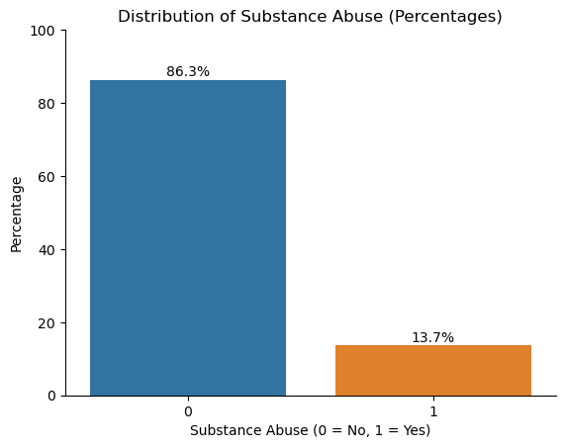

Figure 1: Substance Abuse Diagnosis.
Next, we evaluated the distribution of the ages in the dataset. As we can see in figure 2 there is a relatively even distribution of ages with slightly more middle aged records.
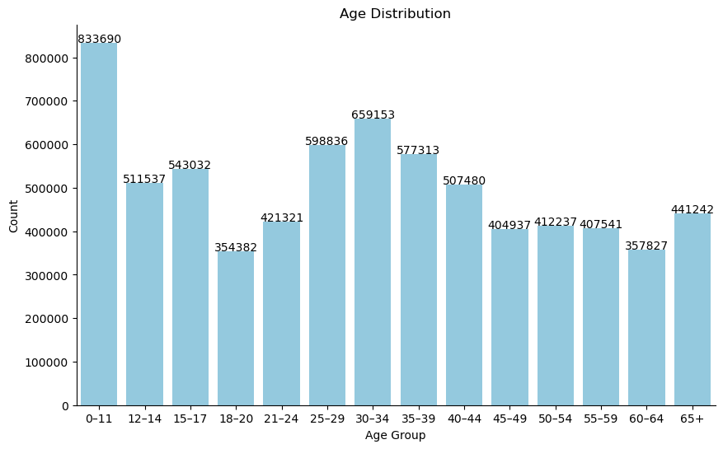
Figure 2: bar graph showing distribution of Age.
Finally, we looked at the distribution of race in the dataset. As seen in figure 3 the greatest population is white. This is important to understand because the model may treat some races differently than others.
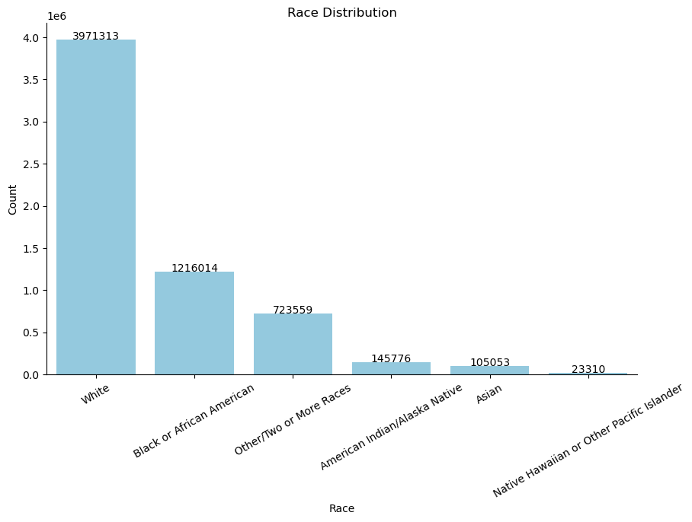
Figure 3: Bar graph showing distribution of race.
Methods.
To build this model predicting substance abuse a series of predictive models were trained using to predict on an engineered target variable from the “SUB” or “substance use diagnosis” variable to simplify id the record was diagnosed with substance abuse disorder or not. logistic regression, decision tree, random forest, gradient boosted trees as well as an MLP neural network were all trained for this predictive model. All five model types were trained using grid search, ensuring that the best parameters were selected to give the model the most predictive power as possible. Additionally, all models were trained on an 80/20 train test split to minimize the effects of overfitting balance the bias variance trade off. Models were evaluated on F2 score. F2 score was selected because the goal of the model is to maximize the true positives detected and minimize false negatives. Evaluating a model this way results in more people being properly diagnosed and hopefully receiving treatment. Evaluating on F2 rewards recall and sensitivity achieving this goal.
After training all 5 models the model selected was the decision tree. This model was likely selected due to its ability to handle categorical data and complex non-linear relationships well. Decision trees are also great at modeling complex interactions in the data. The model performed with and accuracy of 90.1% on the test set and a F2 score of 0.551. The confusion matrix from the resulting predictions of the decision tree can be seen in figure 4 below.
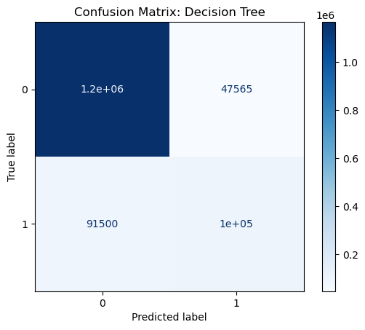
Figure 3: Confusion Matrix: Decision Tree.

The Decesion Tree model selected has over 630,000 nodes, making it a very complex model to find. This in understandable considering the large amount of catagorical features the model is trained upon. Looking at the most important features in the Decesion tree we see that state. Age and the number of mental health diagnosis roported are the the modt important in predicting wheather a patient is suffering from substance abuse disorder. The other ten most important features can be seen in figure 5 below.
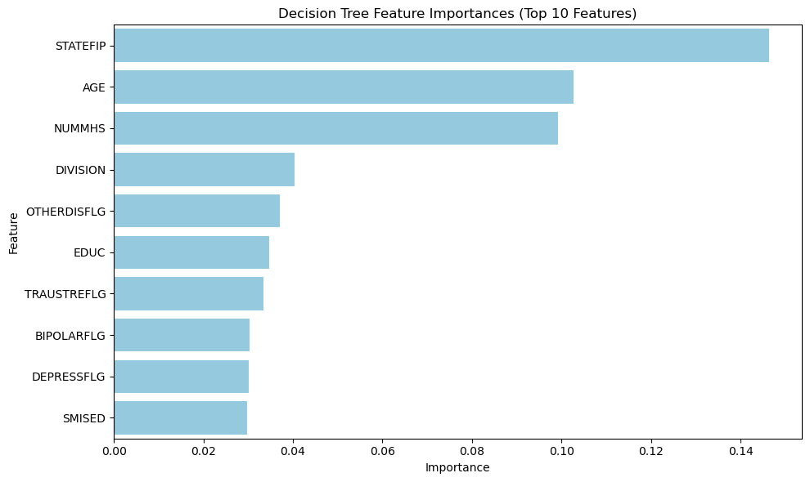
Figure 5: Feature Importance Bar Chart Simplified Decision Tree

Analysis

Overall,the decision tree model performs uqite well. The F2 score of 0.551 shows that the model is successful at identifying most true positives of substance abuse. However, there is still cases of fale positives identified in the model. Additionally the accuracy, although not out target variable, of 90.1 % is very promising and suggests that the model has some merits for implementation.

Conclusion

Although there is a decent portion of false positives predicted in this model, The high accuracy and respectable F2 score suggest that there is some merit in implementation of this model to help identify substance abuse disorders in hospital settings and beyond.

Assumptions
This model is trained on data that is assumed to be accurate. For example, there are many features in the dataset that require the identification or diagnosis of other mental health issues. It is likely that some of this data may be misdiagnosed or under diagnosed. This has the potential of effecting the performance and successful implementation of the model.

Limitations
Although this data set is very robust containing many records and features to train on. There are also some limitations of the sources it comes from. All data collected in this dataset is from either hospitals that are funded or operated by the SAMHSA. Just the fact that the data is collected in a hospital setting is a limitation as it makes it far more difficult to collect this patient information for implementation outside of that hospital setting. Additionally trying to implement this model with data collected outside the SAMHSA umbrella may lead to differing results depending on data collection practices.

Challenges
Challenges of implementing this model are going to come mostly from the non-clinical users. First collecting all the necessary features accurately will be very difficult. It is likely that incorrect and incomplete data will affect the results. Secondly, imputing all that information into the model to get a prediction will require the development and deployment of a user portal that can predict on the data. Thus, requiring a huge investment from either private donors or government agencies.

Future Uses/ Additional Applications
Moving forward this model could be used outside the intended implementation of predicting substance abuse in patients. The model and its features with high importance such as age, state and education could help agencies identify which portions of the population are most susceptible to substance abuse and provide more educational resources to prevent future abuse.

Implementation Plan
This models relatively strong performance has 2 places for implementation. First the model should be implemented in hospitals and clinic settings as a pre-screen base on the patient’s past health information. This model will then flag that the patient is likely to be suffering from a substance abuse disorder, allowing medical professionals to investigate further and look for signs with heightened awareness hopefully getting more patients the help they need. Secondly SAMHSA could make this model available as a tool on their website where concerned family members could anonymously put in the demographic information from a loved one they are concerned about. The tool would then let them know if they are likely suffering from substance abuse. This confirmation tool for families may make them more likely to confront their loved ones and help them get the treatment they need.

Ethical Assessment
There are several ethical considerations when evaluating the merits of this model. First. This model was built on maximizing F2 score and rewarding identifying true positives. As a result, there is also significant number of false positives. False substance abuse disorder diagnosis has the potential of damaging reputations, emotional well-being as well as financial costs. These repercussions must be taken into consideration during any implementation of this model. Additionally, as with any model there is risk of false negatives. Meaning that some who are not properly diagnosed will not get the help and resources they need to get healthy.

Appendix A:

Ten Questions an Audience Would Ask.
- Does this model consider economic factors?
- Could this model be implemented without knowing a person’s mental health background?
- Are there risks of over-diagnosis with implementing this model?
- Is the population trained on representative of the overall US health system?
- All the data in this model is categorical. Could continuous or numerical variables help train a better model?
- Does this model consider any symptoms a doctor may notice?
- How could this model be made available to families to screen loved ones?
- Are there financial expectations as a result of implementing this model for a hospital network?
- Is personal health information used in training this model?
- Are there constraints set forth by governing agencies on how this dataset can used?

Appendix B: Data Dictionary.
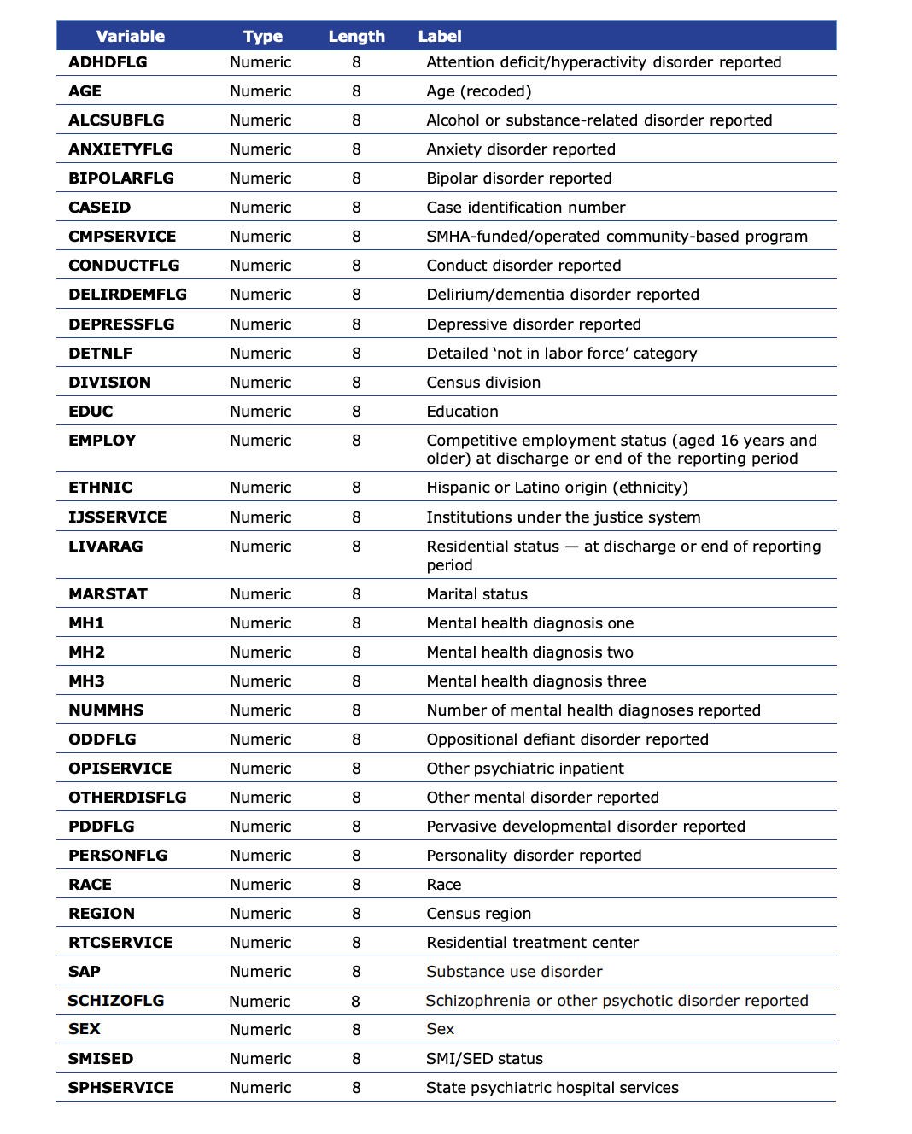

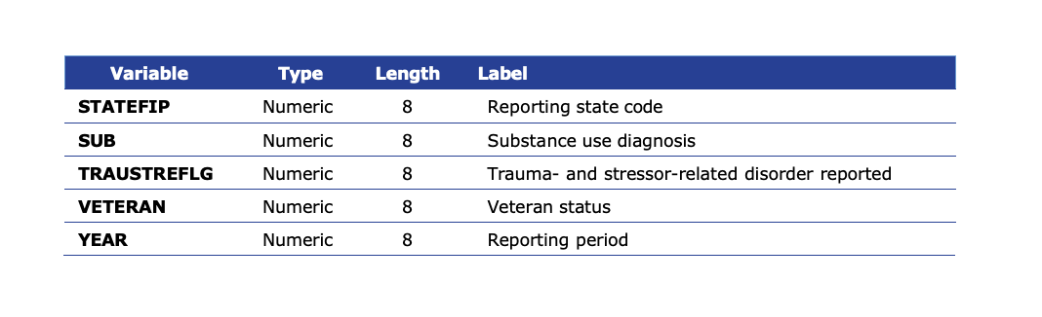

Appendix C:

References
Luo, F., Li, M., & Florence, C. (2021). State-level economic costs of opioid use disorder and fatal opioid overdose — United States, 2017. MMWR. Morbidity and Mortality Weekly Report, 70(15), 541–546. https://doi.org/10.15585/mmwr.mm7015a1
Substance Abuse and Mental Health Services Administration. (2023). Mental health client-level data (MH-CLD). https://www.samhsa.gov/data/data-we-collect/mh-cld-mental-health-client-level-data/datafiles/2023
Serowik, K. L., Yonkers, K. A., Gilstad-Hayden, K., Forray, A., Zimbrean, P., & Martino, S. (2021). Substance use disorder detection rates among providers of general medical inpatients. Journal of General Internal Medicine, 36(3), 668–675. https://doi.org/10.1007/s11606-020-06319-7

